**PHIẾU TRẢ LỜI MÔN Ô NHIỄM ĐẤT (ĐỀ 2)**

|  |  |  |  |  |  |  |  |  |  |  |  |  |  |  |
| --- | --- | --- | --- | --- | --- | --- | --- | --- | --- | --- | --- | --- | --- | --- |
| **STT** | **A** | **B** | **C** | **D** | **STT** | **A** | **B** | **C** | **D** | **STT** | **A** | **B** | **C** | **D** |
| **1** |  |  | **X** |  | **21** | **X** |  |  |  | **41** | **X** |  |  |  |
| **2** |  | **X** |  |  | **22** |  |  |  | **X** | **42** |  |  |  | **X** |
| **3** |  |  | **X** |  | **23** |  |  |  |  | **43** |  |  |  | **X** |
| **4** |  | **X** |  |  | **24** |  |  | **X** |  | **44** |  |  |  | **X** |
| **5** |  |  | **X** |  | **25** |  |  | **X** |  | **45** |  | **X** |  |  |
| **6** | **X** |  |  |  | **26** |  |  | **X** |  | **46** | **X** |  |  |  |
| **7** |  |  |  | **X** | **27** |  |  | **X** |  | **47** | **X** |  |  |  |
| **8** |  |  |  |  | **28** |  |  |  | **X** | **48** |  | **X** |  |  |
| **9** | **X** |  |  |  | **29** |  |  | **X** |  | **49** |  | **X** |  |  |
| **10** |  |  | **X** |  | **30** |  |  | **X** |  | **50** |  |  |  |  |
| **11** |  |  | **X** |  | **31** |  |  | **X** |  | **51** |  |  | **X** |  |
| **12** |  |  |  |  | **32** |  |  | **X** |  | **52** |  |  |  | **X** |
| **13** |  |  | **X** |  | **33** |  |  |  | **X** | **53** |  | **X** |  |  |
| **14** |  |  | **X** |  | **34** |  |  | **X** |  | **54** |  |  |  | **X** |
| **15** |  |  | **X** |  | **35** |  |  |  | **X** | **55** |  | **X** |  |  |
| **16** | **X** |  |  |  | **36** | **X** |  |  |  | **56** |  | **X** |  |  |
| **17** |  | **X** |  |  | **37** |  | **X** |  |  | **57** |  |  |  | **X** |
| **18** |  |  |  | **X** | **38** |  |  |  | **X** | **58** | **X** |  |  |  |
| **19** | **X** |  |  |  | **39** |  |  |  | **X** | **59** |  |  |  | **X(5313)** |
| **20** |  |  | **X** |  | **40** | **X** |  |  |  | **60** | **X** |  |  |  |

**Câu 8:**

**Câu 12:**

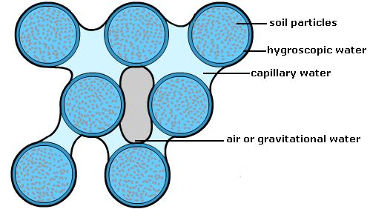

**Câu 23:**

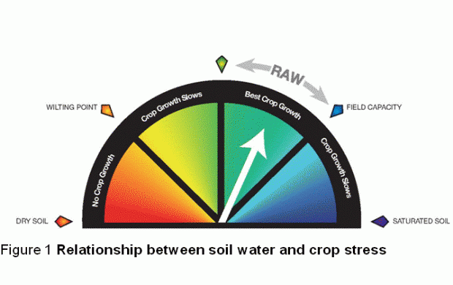

**Câu 50**

